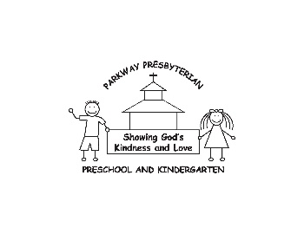

**Authorization to**

**Administer Medication**

**(one form per diagnosis)**

5830 Bethleview Rd

Cumming, GA 30040

678.513.3909

Child’s name: ______________________ Classroom Teacher: __________________

I *authorize* representatives of Parkway Presbyterian Preschool and Kindergarten to *administer the following medication(s)* to my child when they deem it necessary to treat symptoms/illness as described below.

I agree that Parkway Presbyterian Preschool and Kindergarten, its employees and representatives shall be *held harmless* from any suit, action, damages, or claims at law otherwise resulting from or arising out of any injury, accident, or illness which may befall on the child named below while he/she is in the care of Parkway Presbyterian Preschool and Kindergarten.

**TO BE COMPLETED BY PHYSICIAN:**

Medical Diagnosis/Condition: _____________________________________________

*Symptoms* requiring medication: __________________________________________________________________

Directions on how to manage this condition on days child is attending Parkway Preschool **(REQUIRED INFORMATION)** ___________________________________________________________________

MEDICATION:________________________________________________________

DOSAGE: ___________________________________________________________________

(specific amount- not “as directed”)

MEDICATION:________________________________________________________

DOSAGE: ___________________________________________________________________

(specific amount- not “as directed”)

ALL MEDICINES TO BE KEPT/ADMINISTERED AT PRESCHOOL MUST BE MANAGED THROUGH THE OFFICE

__________________________________ _______________

Parent/Guardian Signature Date

__________________________________ _______________

Physician Signature Date